--IN School committee--

October 5, 2021

ORDERED:

That Superintendent Recommendation #21-293, Approval of a Request of a Grade Level Expansion to Include Kindergarten at the Ecole Francaise Greater Boston (EFGB) be adopted as follows: that the School Committee approve a request of a grade level expansion to include kindergarten at the Ecole Francaise Greater Boston (EFGB) located at 799 Concord Avenue, Cambridge Massachusetts.
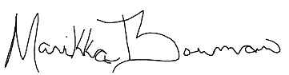
A true copy:
Attest:

Manikka Bowman
Vice-Chair of the Cambridge School Committee

c: Superintendent

